FPT SOFTWARE HO CHI MINH CITY
VIET NAM NATIONAL UNIVERSITY HO CHI MINH CITY
UNIVERSITY OF SCIENCE
 



REPORT MOCK PROJECT
WHEELCHAIR ACCIDENT DETECTOR
WAD

GROUP 4
- Ha Minh Khue
- Nguyen Hoang Quoc Vinh
- Le Chi Thanh

Ho Chi Minh City, August 3, 2018.

ACKNOWLEDGEMENT

First of all, I would like to express our gratitude toward trainers (Mr.Phuong and Mr.Danh), being from FGA Department, assigned to instruct and provide us guidance in the Internship period. During the first process regarding theoretical concepts, not only they impressed us with his deep knowledge about embedded field, they also often gave us for advices about technical problems as well as necessary experience for the job requirement. Moreover, during the mock project, despite being so busy with their work, they occasionally checked out our processes and provide necessary instructions.

Secondly, I was also grateful for the supports from Mr. Lang The Hung – Admin of class. Mr. Hung was the one who responsible about the company policies, regulations and arranged infrastructure for us. He always assured that we were able to enjoy the working environment within the FSOFT Company.

Finally, I would like to express our appreciation toward FSOFT Company, for accepting and giving us a chance to experience the real working environment at the company and creating an ideal condition for working and finishing the Internship period smoothly.

ABSTRACT

Population aging and accident are a common problem which is affecting in many countries, not only in developed countries but also in developing countries. Currently, in Taiwan, is over 2 million on 75 age and patient, reaching 8.86% of the population. Especially, the number of they jumps from 21,68% to 8,86% in 2036. So it needs to be determined first. The figures show that about one-third of over 65 and patient, fell and the relative or other don't know this. This is a danger and influences their life if no any supervisions. In our project, WHEELCHAIR ACCIDENT DETECTOR(WAD), can solve a bit of this problem. It is attached in the wheelchair and if a speed of one is over a limited speed, the sensor in the UDOO Neo sends a warning sign to the supervisor to process on time.

TABLE OF CONTENT

ACKNOWLEDGEMENT………………………………………………1
ABSTRACT……………………………………………………………...2
TABLE OF CONTENT…………………………………………………3
LIST OF FIGURES……………………………………………………..4
LIST OF TABLES………………………………………………………5
- PROBLEM………………………………………………………….6
- OVERVEW SYSTEM……………………………………………...6
- Block diagram……………………………………………………6
- Devices…………………………………………………………...6
  - Module Lora SX1278 433MHz…………………………..8
  - USB UART Lora SX1278 Transmission…………………9
  - Connection Lora with PC and microcontroller…………..10
  - Microcontroller UDOO Neo……………………………..10
  - UDOO Neo Motion Sensor………………………………11
    - Accelerometer and Magnetometer: FXOS8700CQ…..11
    - Gyroscope: FXAS21002C……………………………13
- User Interface……………………………………………………14
- OPERATING PRINCIPLE……………………………………….15
- CONCLUSION…………………………………………………….16

LIST OF FIGURES

Figure 1: Block diagram project
Figure 2: Modle Lora SX1278
Figure 3: USB UART Lora SX1278 Transmission.
Figure 4: Modes of the module
Figure 5: Configuring modes
Figure 6: Set up specifications for Lora
Figure 7: Overview UDO Neo
Figure 8: User Interface
Figure 9: Operating principle
Figure 10: The components of UDOO Neo
Figure 11: The components of FXOS8700CQ
Figure 12: The components of FXAS21002C

LIST OF TABLES

Table 1: The value of registers
Table 2: The value from FXOS8700CQ register

- PROBLEM
Nowadays, the number of the aged and injured patient or the other must be alone increasingly reaches. When they have trouble, they have no any help, especially movement. So, at least, they have a wheelchair to be move easily. In the accidents which related to them, falling wheelchair is one of it, affecting their life directly or they can even die. To prevent it, we need to supervise and support immediately. In the digital technology (as IoT-Internet of thing), this problem is process so easily with UDOO Neo.
In our project, we use UDOO Neo, 2 module Lora and software on PC to announce a warning sign when they have trouble (falling wheelchair) then we can help them on time.

- OVERVIEW SYSTEM
- Block Diagram

SENSOR ON
WHEEL
CHAIR

PC

LORA 1

UDOO
NEO

LORA 2

Figure 1: Block diagram project

- Devices
  - Module Lora SX1278 433MHz
Lora is a promising low-power, long range wireless transmission protocol developed by SEMTECH as part of the emergence of Internet of Things (IoT). Simply put, it is a method for sending data separate from wifi, Zigbee or Bluetooth. Its low power consumption amidst very long range of transmission (up to 10 km) makes it a very good choice for microcontroller systems.
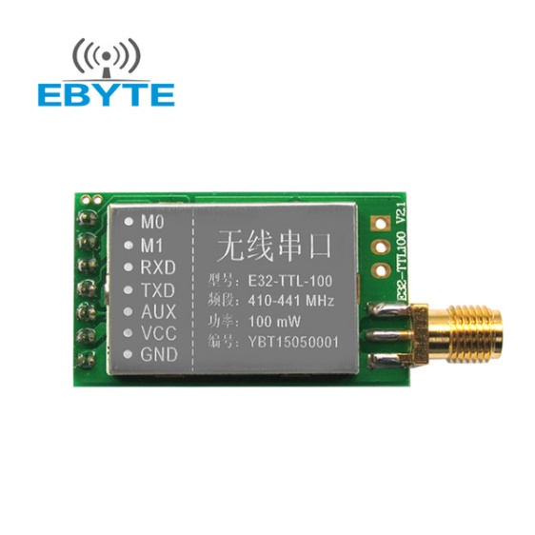
Figure 2: Modle Lora SX1278

Here’s the specifications for the module:
Module size:21*36mm
Antenna type: Standard SMA antenna (FREE)
Power supply:2.3V-5.5V DC
Communication level:5.2V(max)
Transmission distance:3000m(max)
Maximum power:2dB(100mW)
Air rates:2.4Kbps
Emission current:130mA @ 100mW
Receiving current:13.5mA @ Mode 0, Mode 1
Sleep Current:2.0uA(M1=1,M1=0)
Emission length:256 Byte
Receive length:256 Byte
Communication Interface: UART
RSSI support: Yes
Working frequency:410MHz-441MHz(Default 433MHz)
Operating temperature:-30?~+85?
Receiver sensitivity:-130dBm @ 1.2Kbps

  - USB UART Lora SX1278 Transmission.

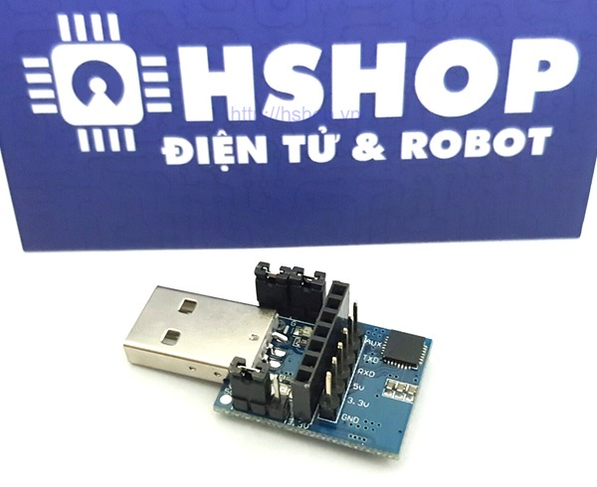
Figure 3: USB UART Lora SX1278 Transmission.

It turns out, M0 and M1 are used to set the modes of the module. There are four modes: normal, wake up, power-saving and sleep. Here’s a useful table:
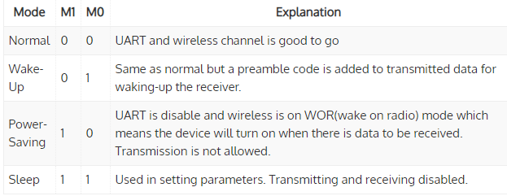
Figure 4: Modes of the module

In our project, WAD, to Lora operates, we should set normal mode for it, to transmit and send data between modules, then it posts data to PC.

PC, received data, process it by user interface on PC.

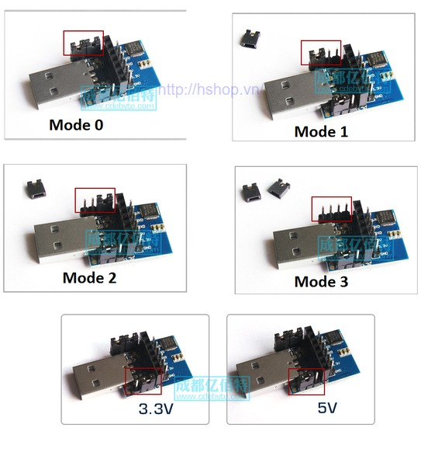
Figure 5: Configuring Modes

  - Connection Lora with PC and microcontroller
Step 1: Connecting Lora with devices(PC and UDOO Neo Kits)
Note: how to connect Lora with UDOO Neo
- M0,M1: to ground.
- RX → TX, TX → TX
- AUX: No connection.
- Vcc: 3.3V
- GND: to ground.

Step 2: Configuring the same specification of 2 Lora modules by RF_Lora_Setting_EN_V2.7
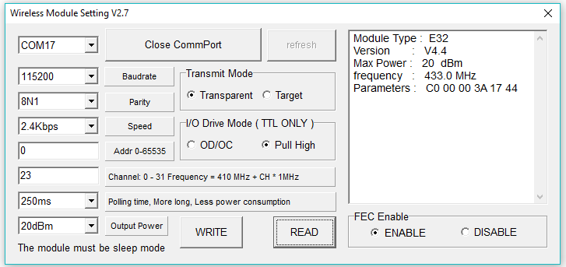

Figure 6: Set up specifications for Lora

Note: to configure specifications for Lora, we set up mode 3(mode Sleep).

Step 3: Sending and receiving for them.

Step 4: PC gets data and displays warning notification.

  - Microcontroller UDOO Neo

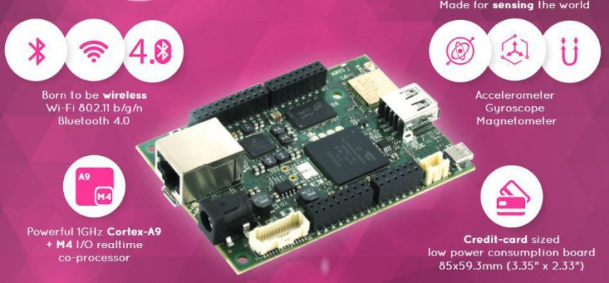

Figure 7: Overview UDO Neo

Reference:
https://www.udoo.org/docs-neo/Introduction/Introduction.html

  - UDOO Neo Motion Sensor
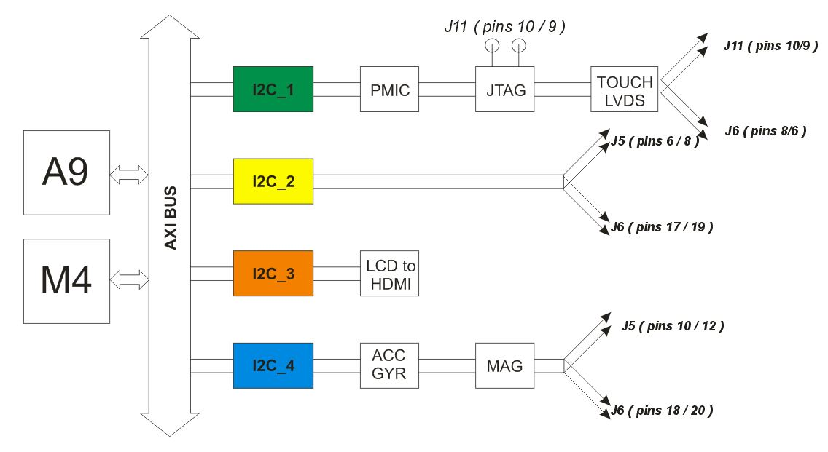
UDOO Neo is equipped with 9-axis motion sensors: accelerometer, magnetometer and gyroscope. Accelerometer and magnetometer are embedded on the same Freescale chip, that is FXOS8700CQ, the gyroscope is a single FXAS21002C chip. They communicate with i.MX 6SoloX over I2C bus number 4. They can be accessed by M4 core and also by A9 core. They can be used in ping mode, asking the values to the sensors, or in interrupt mode.
Figure 10: The components of UDOO Neo

    - Accelerometer and Magnetometer: FXOS8700CQ
FXOS8700CQ is a small, low-power, 3-axis, linear accelerometer and 3-axis, magnetometer combined into a single package. The device features an I2C with 14-bit accelerometer and 16-bit magnetometer ADC resolution along with smart-embedded functions.

FXOS8700CQ has dynamically selectable acceleration full scale ranges of ±2g / ±4g /±8g and a fixed magnetic measurement range of ±1200μT. Output data rates (ODR) from 1.563 Hz to 800 Hz are selectable by the user for each sensor. Interleaved magnetic and acceleration data is available at ODR rates of up to 400 Hz. FXOS8700CQ is guaranteed to operate over the extended temperature range of -40 °C to +85 °C.

I2C address: 0x1E

To read accelerometer and magnetometer filed data: Configure I2C protocol between Udoo Neo and FXOS8700CQ. Use I2C Write data to register function to initialize operation mode for FXOS8700CQ. There are many registers but we just focus on some registers to get the sensor value.
Register | Address | Value
FXOS8700CQ_CTRL_REG1 | 0x2A | 0x1D*
FXOS8700CQ_CTRL_REG2 | 0x2B
FXOS8700CQ_F_SETUP_REG | 0x09 | 0x01
FXOS8700CQ_M_CTRL_REG1 | 0x5B | 0x9F
FXOS8700CQ_M_CTRL_REG2 | 0x5C | 0x20
FXOS8700CQ_XYZ_DATA_CFG_REG | 0x0E | 0x00

Table 1: The value of registers

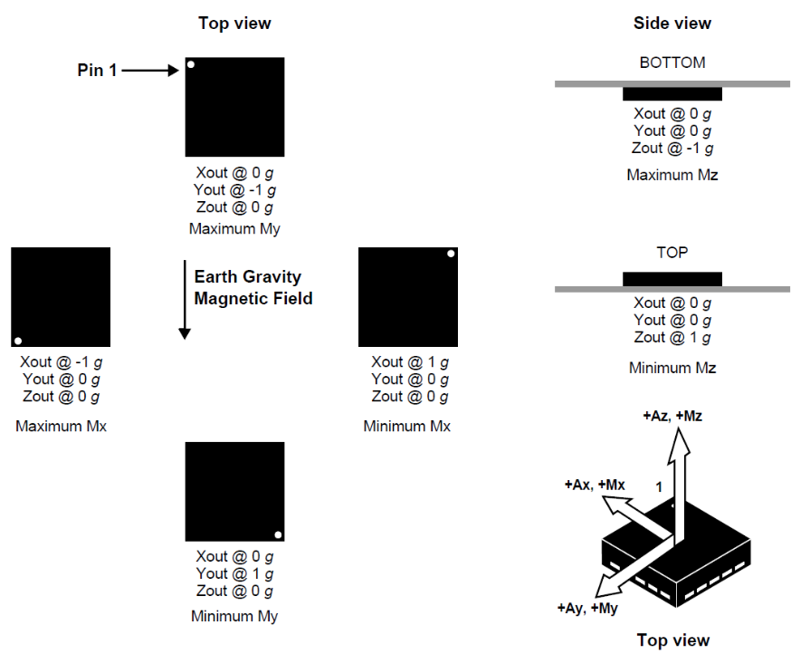
Note: Before configure operation mode for sensor, we must put it to standby mode first (by set bit 0 of CTRL_REG1 to 0). After configuration, we put sensor to active mode again to read sensor value (by set bit 0 of CTRL_REG1 to 1).

Figure 11: The components of FXOS8700CQ

Use I2C Read data from register function to get accelerometer and magnetometer value from FXOS8700CQ

Register | Address
FXOS8700CQ_WHO_AM_I_REG | 0x0D
FXOS8700CQ_OUT_X_MSB_REG | 0x01  …  0x06
FXOS8700CQ_OUT_X_LSB_REG | 0x01  …  0x06
FXOS8700CQ_OUT_Y_MSB_REG | 0x01  …  0x06
FXOS8700CQ_OUT_Y_LSB_REG | 0x01  …  0x06
FXOS8700CQ_OUT_Z_MSB_REG | 0x01  …  0x06
FXOS8700CQ_OUT_Z_LSB_REG | 0x01  …  0x06
FXOS8700CQ_MOUT_X_MSB_REG | 0x33  …  0x38
FXOS8700CQ_MOUT_X_LSB_REG | 0x33  …  0x38
FXOS8700CQ_MOUT_y_MSB_REG | 0x33  …  0x38
FXOS8700CQ_MOUT_y_LSB_REG | 0x33  …  0x38
FXOS8700CQ_MOUT_z_MSB_REG | 0x33  …  0x38
FXOS8700CQ_MOUT_z_LSB_REG | 0x33  …  0x38

Table 2: The value from FXOS8700CQ register

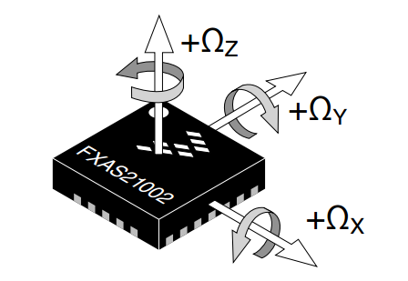
    - Gyroscope: FXAS21002C
Figure 12: The components of FXAS21002C

3-Axis Digital Angular Rate Gyroscope FXAS21002C is a small, low-power, yaw, pitch, and roll angular rate gyroscope with 16 bit ADC resolution. The full-scale range is adjustable from ±250°/s to ±2000°/s. It features I2C interface. FXAS21002C is capable of measuring angular rates up to ±2000°/s, with output data rates (ODR) from 12.5 to 800 Hz.

An integrated Low-Pass Filter (LPF) allows the host application to limit the digital signal bandwidth. The device may be configured to generate an interrupt when a user-programmable angular rate threshold is crossed on any one of the enabled axes. FXAS21002C is guaranteed to operate over the extended temperature range of –40 °C to +85 °C.

I2C address: 0x20

To read gyroscope field data: Configure I2C protocol between Udoo Neo and FXAS21002C, Use I2C Write data to register function to initialize operation mode for FXAS21002C, Use I2C Read data from register function to get accelerometer and magnetometer value from FXAS21002C.

- User Interface
WAD (Wheelchair Accident Detector) is management software that links with the sensor attaching to the wheelchair. This software has the mission to notify the users (doctor, nurse, manager,…) that there is an accident occur with one of the wheelchair users , when it receives an accident signal.

WAD is using Excel as a database. Every change on the information will instantly change the data in the Excel file “ImportData”.

WAD reads the signal from the LORA through a serial port component. There are two kind of signs which are “Accident signal” and “Safety confirm signal”. The “Accident signal” would turn the status column of the wheelchair which has the ID match with the ID signal into red color along with an alarm sound, and the other signal will change it back to green.

WAD has some basic manage feature like: add a new wheel chair, modify an available wheelchair and delete a wheelchair.

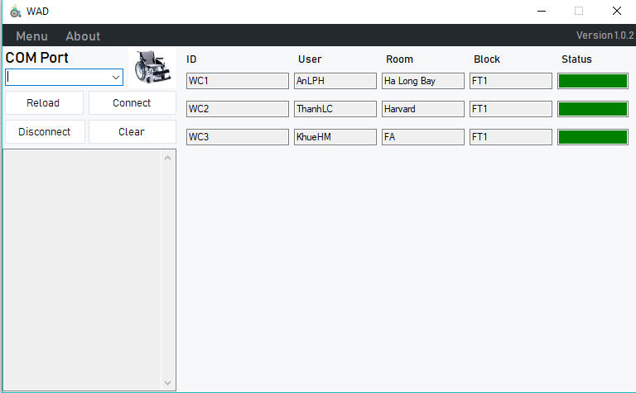
Figure 8: User Interface

After getting the sign from Lora 2, PC will handle it and display the warning sign if the speed is over limited velocity.
There are components in one:
COM Port: to connect to USB UART
The utility tools as Reload, Connect, Disconnect and Clear, helping us hardware by the user interface easily.
The empty under them: to display notifications connecting with Lora 2
The right work: patient information (ID, Name, Room, Block and Status: safety or danger)
Otherwise, we add the others in Menu tool if there are many people supervised.

- OPERATING PRINCIPLE
It is possible to see the block diagram again

SENSOR ON
WHEEL
CHAIR

PC

USB
UART
UART Wireless Connection

LORA 1

UDOO
NEO

LORA 2

Figure 9: Operating principle
Sensor on wheelchair of function can identify a over speed of one and transmit to microcontroller (UDOO Neo). When the speed overcomes, UDOO Neo gets it and sends to module Lora by UART. Then Lora 1 mails to Lora 2 through wireless connection. To 2 modules link them, we can setup the same specifications to do this. Lora 2 receives it and deliveries to PC. By software (user interface), PC can deal with it and get a warning sign to supervisor to handle on time. Also, the project is equipped a press and button. If the patient is dangerous, they can press the button to sign to the nearest supervisor and send the sign to the system once again if here is not no one.

- CONCLUSION
There is a small project the we have done in the Internship, but it has a high applicability int the life, especially the older or the patient. Also, it helps them fix a bit of the problem.
For the purpose of developing an idea smart wheelchair, connected with module Lora SX1278, I had been studying and researching related journals and papers regarding the topic field itself, as well as revising associated Embedded knowledge and C programming language. This mock project is an example of one. For the hardware part, a module of Lora SX1278 is used to transmit and receive data and a sensor on UDOO Neo get a speed to send Lora. The project has equipped our group with comprehensive knowledge in various processes. I hope to apply the understanding of this area to other area of IoT in the future, as well as to expand the existing work to be more friendly to real-life situations.

[1] FXOS8700CQ Datasheet
[2] FXAS21002C Datasheet
[3] Udoo Neo Data sheet
[4] Fatal wheelchair-related accidents in the US…- NCBI
[5] Lora SX1278 Datasheet

